LAB ASSIGNMENT 3 Genetic Algorithm & Constraint Satisfaction Problem
Course: CSC-462 Artificial Intelligence
CLO: CLO-6 Implement search algorithms, CSPs, and optimization methods
Total Marks: 25

PART A Genetic Algorithm (GA) (12 Marks)
Problem A1 Max-One GA (Coding Required) (6 Marks)
Write a Python program that implements a Genetic Algorithm to solve the Max-One problem for a chromosome length of L = 16 bits.
Your program must:
- Initialize a population of size 40 with random 0/1 chromosomes.
- Evaluate fitness as the number of 1s in the chromosome.
- Perform roulette-wheel selection to choose parents.
- Apply single-point crossover using crossover probability Pc = 0.7.
- Apply bit-flip mutation using mutation probability Pm = 0.05.
- Stop when a chromosome of all 1s is produced or 500 generations are completed.
Output Requirements:
- Print the best chromosome and its fitness for each generation.
- Print the generation number at which the optimal solution is found (if found).
- If not found, print "Optimal solution not found".

Problem A2 GA Behaviour Analysis (6 Marks)
After writing the code in A1, answer the following questions based on your program’s output:
a. How many generations were required to reach the optimal chromosome?
b. What happens when you increase mutation probability Pm from 0.05 → 0.20?
c. Why are Genetic Algorithms less likely to get stuck in local maxima compared to

PART B Constraint Satisfaction Problem (CSP) (13 Marks)
Problem B1 Australia Map Coloring CSP (5 Marks)
Write a Python program that solves the Australia Map Coloring Problem using Backtracking Search.
Use the seven regions shown in Fig. 35 of the lab manual:
WA, NT, SA, Q, NSW, V, T
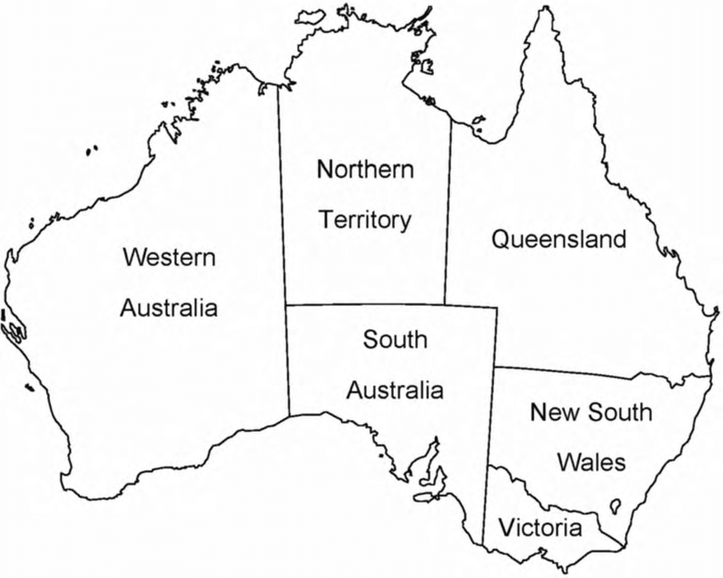
Requirements:
- Variable domains: {Red, Green, Blue}
- Constraint: Adjacent regions must not have the same color.
- Implement a backtracking solver that checks consistency at each step.
Output:
- Print the final color assigned to each region.
- Print the total number of backtracking steps performed.

Problem B2 CSP with Forward Checking (5 Marks)
Extend your solution from B1 by adding Forward Checking.
Your improved program must:
- Reduce domain values of neighboring variables after assigning a value.
- Stop early if any region’s domain becomes empty.
Output:
- Print the solved assignment.
- Compare the number of backtracking steps with the solution from B1
(Which one required fewer steps? Why?)

Problem B3 4-Queens as a CSP (3 Marks)
Write a Python program to solve the 4-Queens problem using Backtracking + Forward Checking.
Model the problem as:
- Variables: Q1, Q2, Q3, Q4 (each representing a row)
- Domains: {1, 2, 3, 4} (column positions)
- Constraints:
  - No two queens share the same column
  - No two queens lie on the same diagonal
Output:
- Print one valid solution.
- Print number of backtracking steps.

Submission Instructions
Students must submit:
- Python files for each task.
- A short PDF with explanations & screenshots of outputs.
- All code must be original and well-commented.

